When you attend a Face to Face appointment at Level 2, please follow the guidelines below. These are in place to keep everyone safe and reduce the risk of any possible exposure.

GREYMOUTH OFFICE

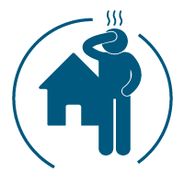
If unwell, stay home
If you are experiencing cold or flu-like symptoms, please phone us and we’ll reschedule your appointment or move the appointment online if possible.

Wear a mask
Please wear a mask while you are at the PHO and during your appointment. If you forget, we can provide one. If you have a condition that prevents wearing a mask, we can see you online instead. If you are hearing impaired, please let us know.

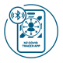
Scan the QR on arrival
Scan in when you arrive using the COVID-19 Tracer app. We will also sign you in manually.

Use hand sanitiser
Use hand sanitiser when arriving and leaving.

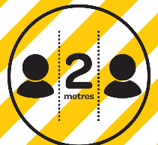
Social distancing
Maintain social distancing of 2 metres where possible while queuing or sitting in the waiting area.

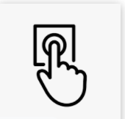
When you arrive, please make your way upstairs. When you are ready, please ring the doorbell to notify the staff that you have arrived.

Thank you

